How to set up and monitor the HVAC program waitlist

- If the HVAC program is full (look at the HVAC1020 Tube and Pipe Fabrication only course to determine it), students can set up a waitlist for the HVAC program on eFServices. HVAC is a full-time, cohort-based program that requires students to take all 7 courses listed in the Academic Planning Guide. HVAC1005, OSHA 30-hour Construction Safety, can be completed separately at any time.

- To add yourselves to the waitlists for any campus or term, follow these instructions:
- Log in to eServices
- Select Courses and Registration, Search for a Course, select the following criteria:
  - Campus – Eden Prairie or Brooklyn Park
  - Semester - Fall or Spring
  - Subject - Heating, Ventilation, and Air Condition (HVAC)
  - Display - All Courses
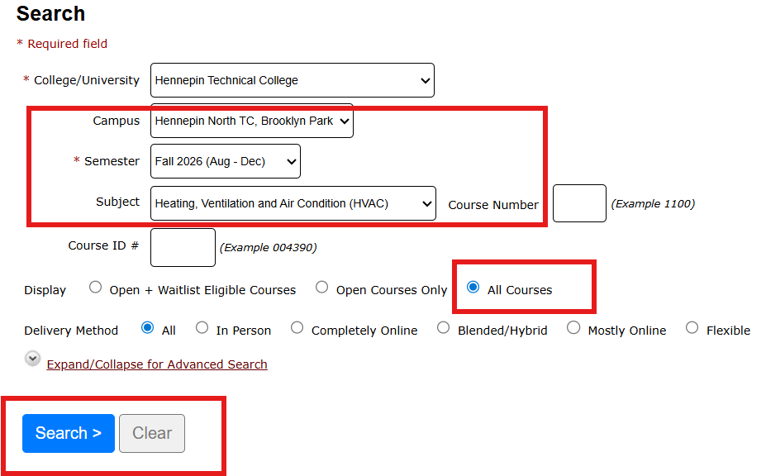
This search will display all HVAC courses; click the “Waitlist” button for HVAC1020, Tube and Pipe Fabrication course only. The system will offer to add you to the waitlist for other sections of HVAC1020 offered at another campus or at a different time at Brooklyn Park campus for the spring term only. If you wish to be added to another campus waitlist, select it as well and click the “Submit” button to confirm adding yourself to the waitlist. You will see how many students are ahead of you on the waitlist for each cohort of the HVAC program.
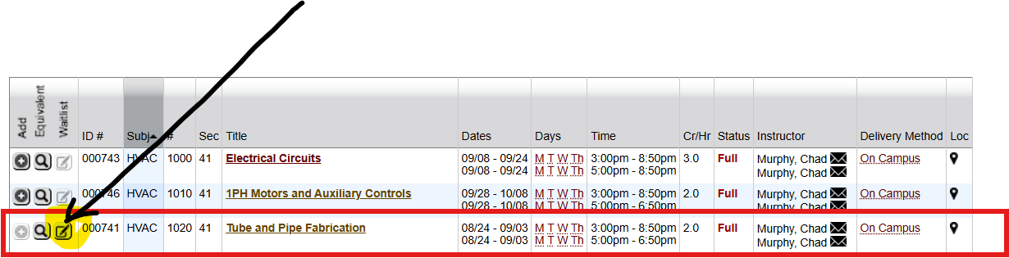

- Students can monitor the waitlist's status by checking the “Review My Plan” tab under the “Courses and Registration” tab on E-Services, or by checking their Hennepin Tech email regularly for notifications about any changes/updates regarding their waitlists.

- If you receive an email to register for HVAC1020, you have only a 24-hour window to enroll for the program, which requires this HVAC1020 course and the rest of the first-term HVAC courses at the same time. Students must enroll in all first-term seven HVAC courses listed on the Academic Planning Guide, including HVAC1020, at once.
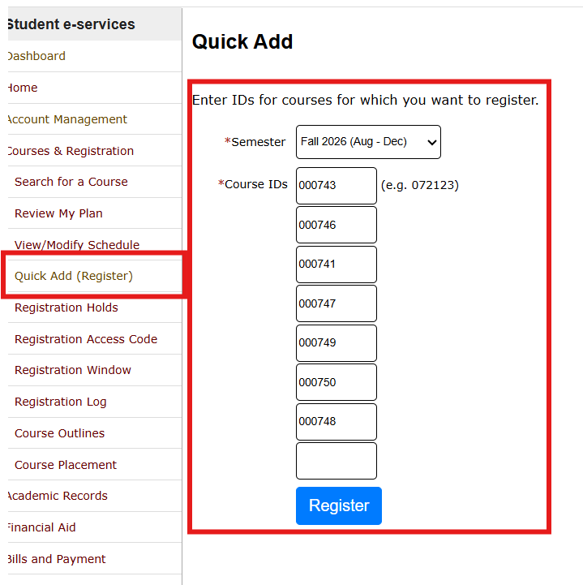
- To do it, students will need to utilize the “Quick Add” (Register) option under “Courses and Registration” (see image below as an example for fall 2026 at Brooklyn Park campus with Chad Murphy), enter the 6-digit Course IDs for all seven courses in the co-requisite group with the same instructor (look at the schedule above), including the one they were waiting for HVAC1020, and register for all seven at once.

- After you register for the seven required HVAC courses, students are recommended add HVAC technical electives during their first term, offered by the same instructor. One credit is required for the Residential Diploma and four for the AAS. However, the HVAC faculty strongly recommends all students take as many technical HVAC electives as possible to gain more knowledge and skills, or to obtain additional certifications to become more employable.

- An example of how to filter your search results by instructor’s first name to receive all the courses students must take in the first term of fall 2026 with Chad Murphy at the Brooklyn Park Campus location. Highlighted in yellow are three technical electives that are highly recommended. HVAC1060 and 1090 must be taken together.
- Students who are not enrolled in the first term HVAC core classes are not allowed to take technical electives.
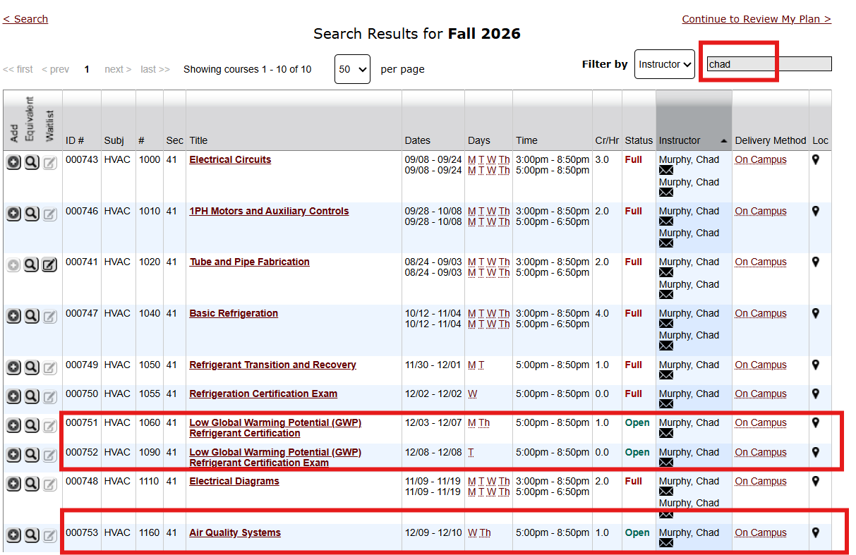

- If you need help, please call the Hennepin Tech One Stop office at 952-995-1300 for phone or come on campus for in-person assistance within 24 hours, so you do not miss your registration window.

